Lab 1.1.2a Environment Setup – Vmware

1. take a screenshot of the VM settings for Server 2019

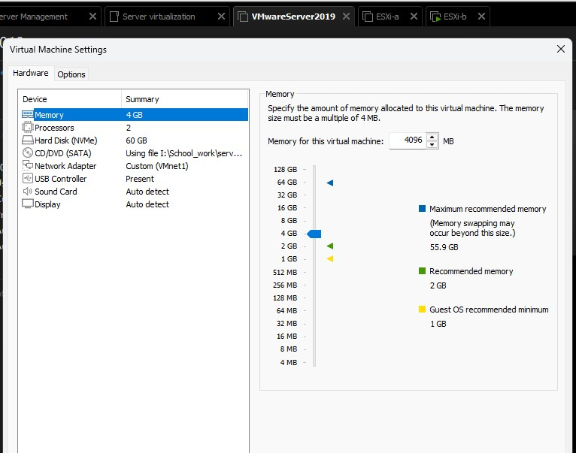

1. take a screenshot of the completed Hardware Table below for  
   grading

|  |  |  |  |
| --- | --- | --- | --- |
|  |  | HARDWARE REQUIREMENTS TABLE | |
| **Host Configuration** |  |  | **Hardware Requirement** |
| Processor: |  |  | 🗹🗹 64-bit x86 processor |
| Number of CPU Cores: |  |  | ⬜ Minimum 2 CPU cores |
| RAM: |  |  | ⬜ Minimum 4 GB RAM  ⬜ 8 GB RAM recommended |
| VT Technology: |  |  | ⬜ Hardware virtualization Enabled  (Intel VT-x or AMD-V) on x64 CPUs |

1. Take a screenshot of the Virtual Network Editor showing configurations  
   for the Vmnets created/configured for this lab.

1. Take a screenshot of the VM settings for ESXi-a, showing all the required configurations to this point

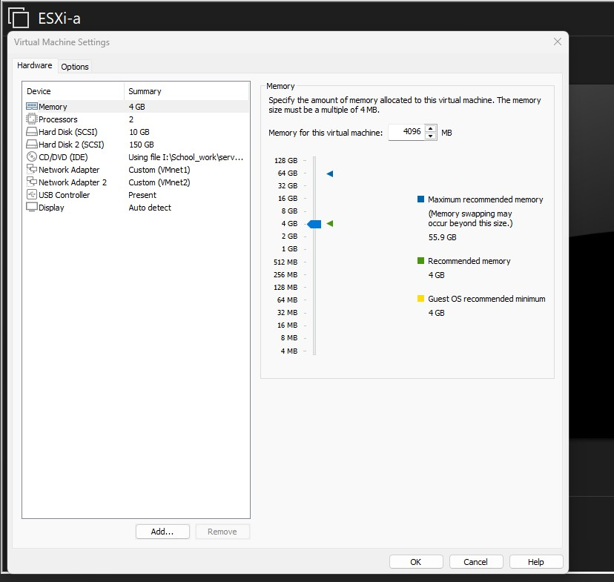

1. Log back into ESXi-a. For grading, take a screenshot of all required  
   configuration changes made above. This will likely require more than one  
   screenshot. One of the screenshots must be of the ESXi home screen as shown  
   in the file “Lab 1.1.2a VMware Sample Explanation With Screenshots”

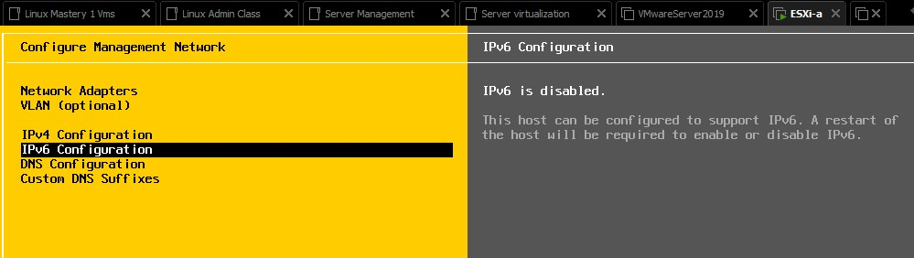

1. Take a screenshot of the VM settings for ESXi-b, showing all the required configurations to  
   this point

1. For grading, take a screenshot of all required configurations for ESXi-b. Every  
   screenshot captured for ESXi-a should also be captured for ESXi-b. This will  
   likely require more than one screenshot, just as it did for ESXi-a

1. Create snapshots of each VM and take a screenshot of each one for grading

